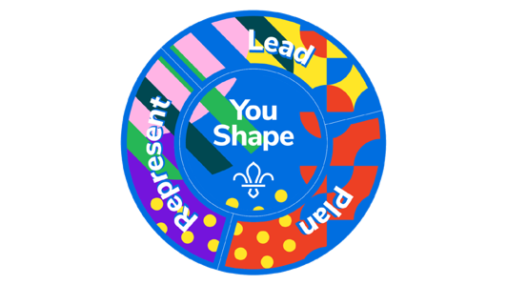
Beavers YouShape Award

At Scouts, Young People learn how to speak up and take the lead.
This award allows them to have their say and provide us with important feedback so we can make Scouting more accessible and enjoyable for all involved.

- Central Badge: Choose one thing you’d like to improve at Beavers. Work with a parent/carer, Young Leader or Leader to make it happen.
- This could be learning a new skill, developing your current talents or interests, or changing something about Beavers.
- Getting Personal: Think about what you are good at and explore the abilities and attributes you would like to develop.

- Plan: Choose an Activity from the following options.
- Think of an idea for a camp or trip and tell a Leader about it.
- Share an idea during a Log Chew.
- Choose a theme for a Beaver meeting with your Leader.
- Help create a new game for other Beavers.

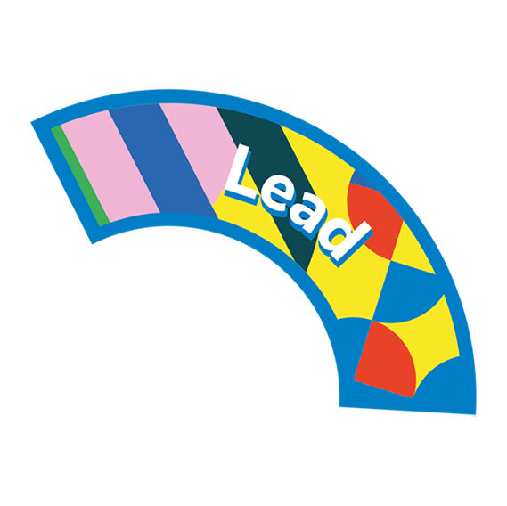
- Lead: Choose an activity from the following options.
- Help a new Beaver feel welcomed into the Colony.
- Lead an activity during a meeting with the help of a Young Leader or Leader.
- Lead a Log Chew for your Colony.
- On a Camp, Lead a game, song, or activity with the help of a Young Leader or Leader.

- Represent: Choose an activity from the following options.
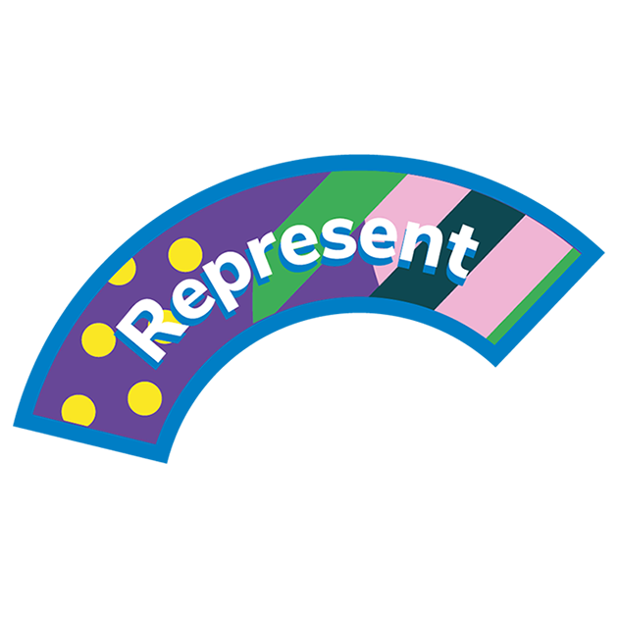
- Tell your Group Trustee Board what you like and don’t like about Beavers.
- Bring a friend to Beavers and help them give it a go.
- Tell a leader about something you’ve learnt at Beavers that you could use to help people in the community.
- Write to a local decision maker, tell them what you like about Beavers, and ask them to help Scouts in your area.

