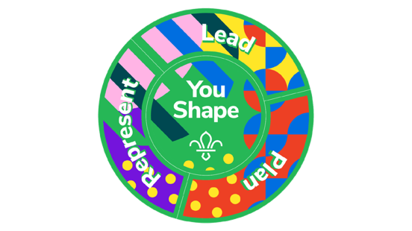
Cubs YouShape Award

At Scouts, Young People learn how to speak up and take the lead.
This award allows them to have their say and provide us with important feedback so we can make Scouting more accessible and enjoyable for all involved.

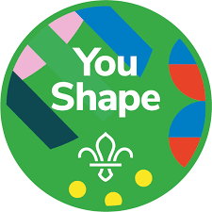
- Central Badge: Choose one thing you’d like to improve at Cubs. Work with a parent/carer, Young Leader or Leader to make it happen.
- This could be learning a new skill, developing your current talents or interests, or changing something about Cubs.
- Getting Personal: Think about what you are good at and explore the abilities and attributes you would like to develop.

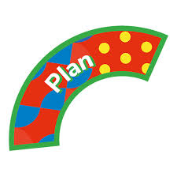
- Plan: Choose an Activity from the following options.
- Think of an idea for a camp or trip and present it to your Pack.
- Think of a way your Pack could achieve a badge requirement and share your idea in a Pack Forum.
- Plan a Cubs meeting with your Leader.
- Help create an activity that helps other Cubs achieve a badge requirement.

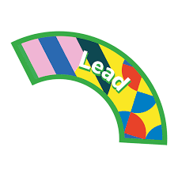
- Lead: Choose an activity from the following options.
- Lead a session that welcomes a new Cub.
- Lead an entire session with the help of a Young Leader or Leader.
- Lead a Pack Forum for your Pack.
- On a Camp, Lead a day of activities and fun for your Pack with the help of a Young Leader or Leader.

- Represent: Choose an activity from the following options.
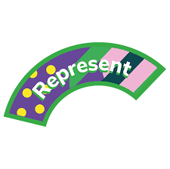
- Tell your Group Trustee Board what you like and don’t like about Cubs.
- Take part in a Scouts activity with young people who aren’t involved in Scouts.
- With your Pack, take part in a project that uses skills you’ve learnt at Cubs to help people in the community.
- Write to a local decision maker, tell them what you like about Cubs, and ask them to help Scouts in your area.

