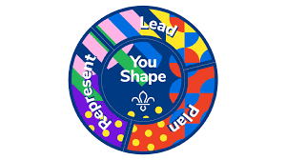
Explorers YouShape Award

At Scouts, Young People learn how to speak up and take the lead.
This award allows them to have their say and provide us with important feedback so we can make Scouting more accessible and enjoyable for all involved.

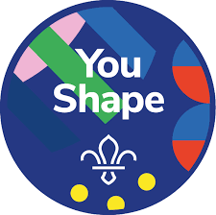
- Central Badge: Choose one thing you’d like to change, improve or deliver for Young People in your Explorers in your Districts and make it happen.
- This could be learning or teaching a new skill, developing your current talents or interests, or changing something about Explorers.
- Getting Personal: Think about what you are good at and explore the abilities and attributes you would like to develop.

- Plan: Choose an Activity from the following options.
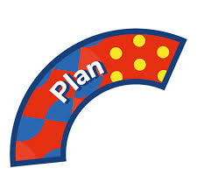
- Plan an event for your District.
- Think of a way to help people at something outside Scouts and share your idea in a Unit Forum.
- Plan an entire programme to help other Explorers achieve a specific skill, goal or badge.
- Create an activity that helps Young People not in Scouts to learn a Scouts Skill.
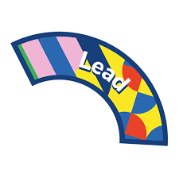
- Lead: Choose an activity from the following options.
- Help a new adult Voulenteer complete their induction.
- Lead an entire session for another Explorer Unit.
- Lead a Unit Forum for your Unit.
- Lead a one-night camp with no Leader. (You’ll need a Nights Away Passport)

- Represent: Choose an activity from the following options.
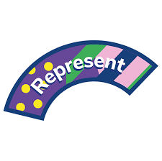
- Tell your District/ County Trustee Board about how Scouts could be improved in your District/ County.
- Identify a group of potential Adult Voulenteer and tell them about about the benefits of Volunteering with Scouts.
- Take part in a project with Explorers from across your Districts that uses skills you’ve learnt at Scouts to help people in the community.
- Work with your GSL, DC, CC to lobby a decision maker about an issue that affects Scouts.

