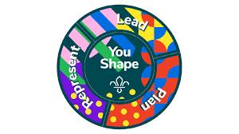
Scouts YouShape Award

At Scouts, Young People learn how to speak up and take the lead.
This award allows them to have their say and provide us with important feedback so we can make Scouting more accessible and enjoyable for all involved.

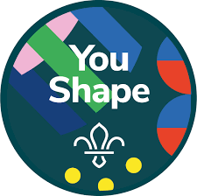
- Central Badge: Choose one thing you’d like to change, improve or deliver for Young People in your Troop or Section, and make it happen.
- This could be learning or teaching a new skill, developing your current talents or interests, or changing something about Scouts.
- Getting Personal: Think about what you are good at and explore the abilities and attributes you would like to develop.

- Plan: Choose an Activity from the following options.
- Plan an event for your Scout Group.
- Think of a way your Troop could achieve a badge requirement and share your idea in a Troop Forum.
- Plan a term of activities with your leader.
- Help create a series of activity that helps other Scouts achieve a badge requirement.
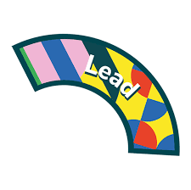
- Lead: Choose an activity from the following options.
- Lead a session that shows older Cubs the best of Scouts.
- Lead an entire session for your Section.
- Lead a TroopForum for your Troop.
- Lead a one-night camp with no Leader. (You’ll need a Nights Away Passport)

- Represent: Choose an activity from the following options.
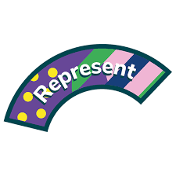
- Tell your Group or District Trustee Board about how Scouts could be improved in your group or District.
- Lead a Scouts activity with Young People who aren’t involved in Scouts.
- Take part in a project with Young People from across your group that uses skills you’ve learnt at Scouts to help people in the community.
- Plan and deliver a Scouts activity for a local decision maker to take part in and show them why they should help Scouts in your area.

